

**Directions to the Northern Kentucky University Health Innovation/Founders Hall Building Atrium**

**Directions to Campus** <https://www.nku.edu/about/directions.html>

**Traveling from Lexington, Kentucky:**

Take I-75 North.  
Continue on I-71/75 North  
Take Exit 185 onto I-275 East  
Follow directions for traveling East on I-275

**Traveling East on I-275 from Greater Cincinnati / Northern Kentucky Airport:**

Take Exit 76 (Three Mile Road/Northern Kentucky University)  
Turn right off of the exit on University Drive  
Turn right at the first stop light onto Kenton Drive.  
Continue straight through campus.  
Turn right into the Kenton Drive Parking Garage (Located directly across from the Student Union).

**Parking** – Kenton Drive Garage

Follow Kenton Drive until you can turn right into the Kenton Drive Garage (see orange arrow on map below). Take a parking ticket when entering the garage.

**Directions to the Building/Meeting Room**

The Health Innovation Center is the copper colored building next to Griffin Hall (see blue arrow on map below).

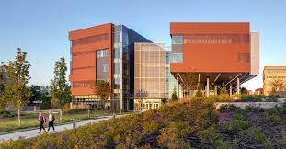

From the garage, the building will be on the left of Griffin Hall.  You will see the walkway that leads to the front entrance (under the HIC sign).  The atrium is on the lowest level.

Here is the web link to the interactive online map. <https://map.nku.edu/#!BLD_2016050816627>

Kenton Parking Garage

Health Innovations Center